Art de Parfum Win Beauty Shortlist Award 2017

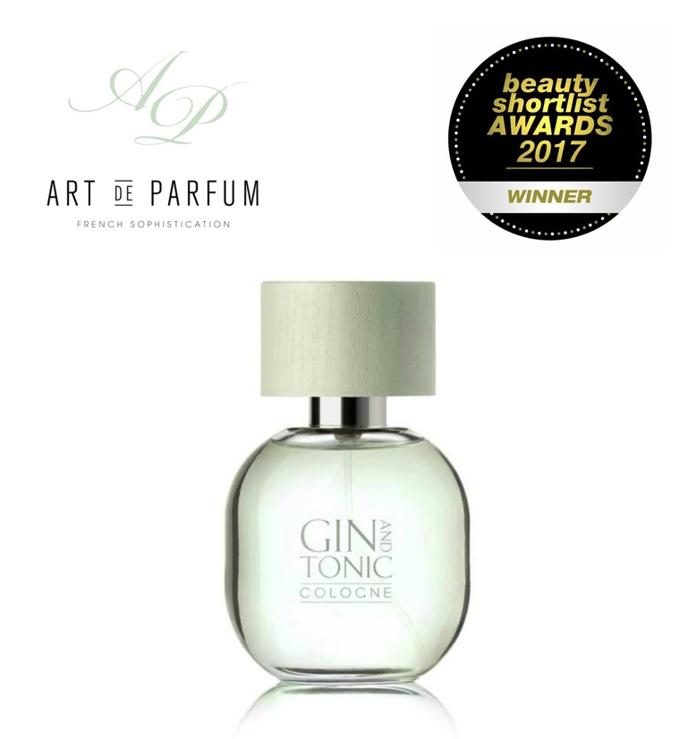
London based, niche perfume house Art de Parfum are proud and privileged to announce they are Beauty Shortlist’s BEST FRAGRANCE WINNER for 2017 announced this month.

The competition was intense and Art de Parfum’s Gin & Tonic parfum was chosen from entries from 38 countries around the world. The award is testament to the tireless work and vision of founder Ruta Degutyte, the brand’s CEO. Each fragrance is 100% made in France and is uncompromising on the issue of ethics and environment. Having spent years as an international marketing consultant for several global brands, Ruta decided to make ethics a core value of her new brand thus making it easy for customers to choose with confidence. All Art de Parfum fragrances are 100% cruelty-free, GMO free, nano free and environmentally-friendly, and free of materials that add to third world exploitation.

Art de Parfum’s winning Gin & Tonic Cologne is as satisfying as an ice-cold G&T after a long day. It is a guilt-free cocktail you can indulge in, with lemon, grapefruit peel, juniper berry, and cucumber notes – this scent is the proverbial crisp white shirt of your wardrobe.

Beauty Shortlist stated “A sparkling debut in 2016 and now BEST FRAGRANCE WINNER for 2017, niche perfume house Art de Parfum’s intriguing yet easy-to-wear twist on juniper, grapefruit, vetiver and cucumber made Gin & Tonic our pick of the year. Spot-on for spring’s brighter days and the warm evenings heading our way, we’ll be wearing this delightfully modern newcomer all summer ….. one of the most modern and notable scents of 2017.”

To see the complete 2017 International Beauty Shortlist Awards winners list, please click here. All Art de Parfum fragrances can be purchased directly through the website at http://www.artdeparfum.com, and shipping is free to all UK mainland addresses. The Art de Parfum fragrances are all extraits de Parfum (20-40% concentrated perfume oils) and cost £108 per 50mls.

Art de Parfum will be showcasing their full of range of parfums at the prestigious Esxense in Milan from 23rd to 26th March 2017 www.esxence.com.

Press:
Sally Keeble
Mercer Keeble PR
E: sally@mercerkeeblepr.com
www.mercerkeeblepr.com

